Student Name | G. Manasa
Student Registration Number | 241U1R3007 | Class &Section: CSE(DS)
Study Level: UG/PG | UG | Year &Term: I & II
Subject Name | Digital Electronics

Name of the Assessment | Reflective Journal -10
Date of Submission | 14/09/2025

Reflective Journal Template
Journal Entry Guidelines | Description
1. Experience (Class Content) | Briefly describe the topics or concepts discussed during the class.
2. Feelings (Emotional Reactions) | Share your emotional reactions and thoughts during the class.  How did you feel while learning this theory?  Did the class evoke specific emotions or questions?
3. Learning (Key Insights) | Reflect on what you learned from the class.  Highlight the key insights or fundamental concepts you gained from the class.
4. Application (Practical Use) | Describe how you plan to apply the theory you've learned in real-life situations or in your academic/career endeavours.  Explain the practical utility of this theory.

Sample Journal Entry

Date | 14-09-2025
Journal Entry Topic | Sequential Logic Design-3  SISO, SIPO, PISO, PIPO, Ring counter and twisted ring counter, Counters: Design of Asynchronous and Synchronous counters.
1. Experience (Class Content) | In this module, I explored the world of sequential circuits in greater depth. Previously, I had some basic understanding of flip-flops and latches, but now I saw how they are combined to form registers and counters. The class started with shift registers where data moves step by step, either serially or in parallel. At first, I felt the different names (SISO, SIPO, PISO, PIPO) were too technical, but when my teacher drew the block diagrams and explained how data flows, everything became clearer.  Later, we learned about ring counters and twisted ring (Johnson) counters. I found them very interesting because they work like a cycle or loop, generating specific patterns that can be used in digital systems. Finally, we discussed asynchronous and synchronous counters. I noticed that synchronous counters are more accurate and widely used because all flip-flops change together.  Working through examples and solving problems helped me connect the theory with real applications. It was almost like solving puzzles figuring out how data will shift or how the counter will count the sequence.
2.Feelings (Emotional Reactions) | At the beginning, I felt a bit overwhelmed because so many new terms like SISO, PISO, etc., were introduced at once. But as I practiced, I felt curious and excited because I understood how data moves inside registers and how counters keep track of sequences. When I solved small design problems, I felt more confident and happy, especially because I could finally imagine how these concepts are used in real systems like computers and communication devices.
3. Learning (Key Insights) | 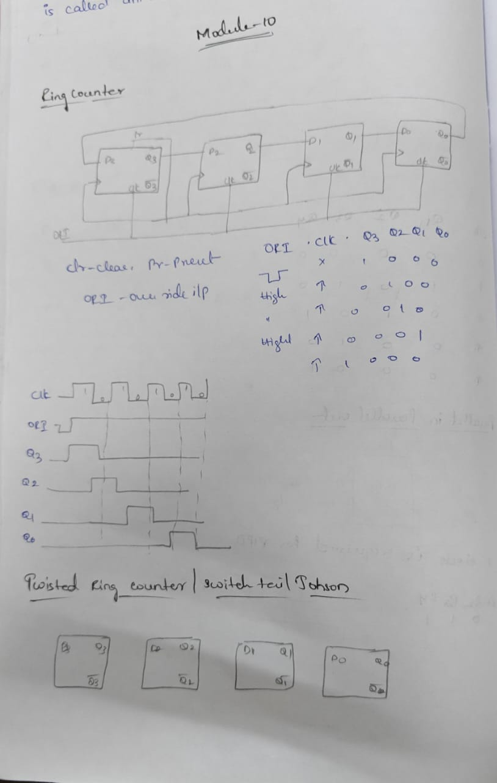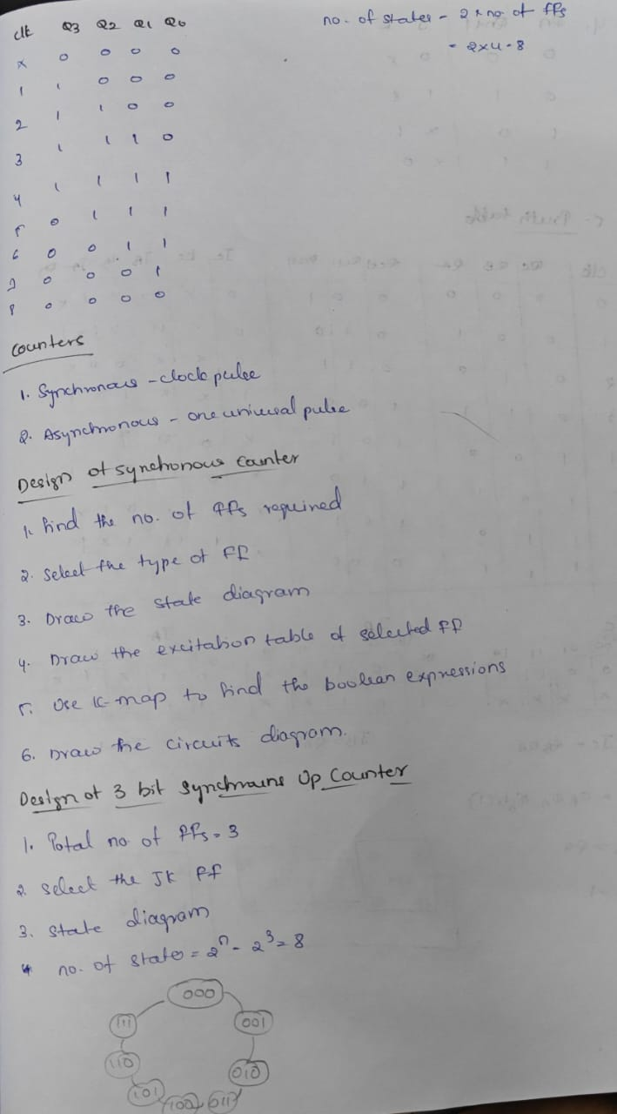  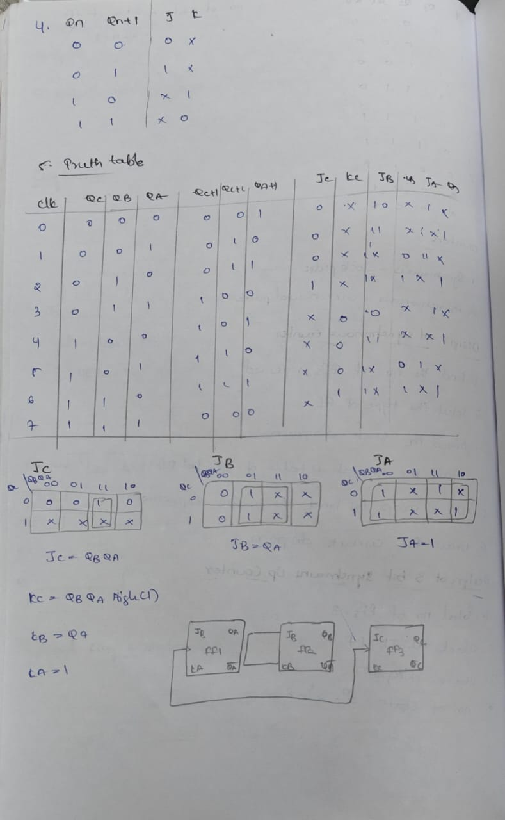
4. Application (Practical Use) | Shift Registers  These are used for serial-to-parallel, parallel-to-serial, serial-to-serial, and parallel-to-parallel data conversions and transmissions.  - SISO (Serial-In Serial-Out):  Data is loaded serially and read out serially, often used in applications requiring serial data storage or delay.  - SIPO (Serial-In Parallel-Out):  Used to convert serial data into parallel format, as seen in digital communication systems for receiving data.  - PISO (Parallel-In Serial-Out):  Converts parallel data into serial data, for example, when a computer needs to send data over a serial line.  - PIPO (Parallel-In Parallel-Out):  Stores data in parallel and outputs it in parallel, essentially acting as a temporary storage or buffer.  Ring Counters and Twisted Ring Counters  These devices use a feedback mechanism in a shift register to cycle through specific patterns of bits.  - Ring Counter:  A simple configuration that shifts a single '1' bit around the register, creating a sequence of distinct states.  Applications:  - Timing Signal Generation: Producing specific sequences of timing signals.  - Frequency Division: Dividing a clock frequency by a factor equal to the number of stages in the ring.  - Control in Finite-State Machines: Implementing the control logic for sequential circuits in hardware (FPGAs and ASICs).  Asynchronous and Synchronous Counters  These are fundamental building blocks in sequential logic for counting.  - Asynchronous Counters:  Also called ripple counters, they are not synchronized by a single clock signal. The output of one flip-flop triggers the next, creating a ripple effect.  Applications:  - Simple Event Counting: For counting events where precise timing isn't critical.  - Time Delays: Used in circuits to create specific time delays.  Synchronous Counters:  All flip-flops in the counter share the same clock signal. They transition to a new state simultaneously on the clock pulse, providing precise and predictable behavior.  Applications:  - Precise Frequency Division: Generating precise divisions of a clock signal.  - Event Sequencing: Controlling the order of operations in complex digital systems, such as within the logic of a microcontroller or digital signal processor.  - Watchdog Timers: In microcontrollers to monitor system operation and reset the system if it hangs.
Conclusion | This module gave me a strong foundation in sequential logic design. I understood how shift registers, ring counters, and synchronous/asynchronous counters play a major role in digital electronics. The most important realization for me is that these small building blocks are everywhere in real-world devices from the clock on our phone to the processors inside a computer. I experienced a journey from confusion to clarity, from nervousness to confidence. The knowledge I gained here will not only help me in exams but also give me the ability to understand how real digital systems are designed. I feel more motivated to learn advanced digital electronics and explore how these simple circuits grow into complex systems.

